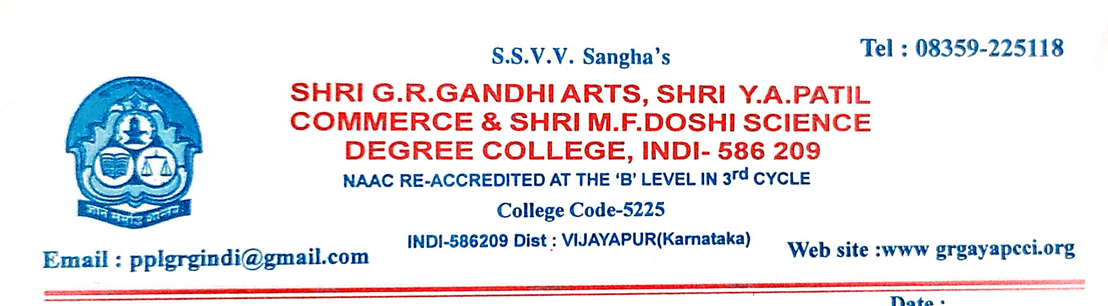
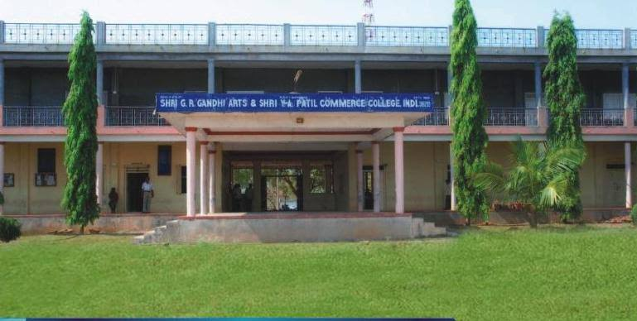
CRITERION VII - INSTITUTIONAL VALUES AND BEST PRACTICES
7.1.7 - The Institution has disabled-friendly, barrier free environment
1. Built environment with ramps/lifts for easy access to classrooms.
2. Disabled-friendly washrooms
3. Signage including tactile path, lights, display boards and signposts
4. Assistive technology and facilities for persons with disabilities (Divyangjan) accessible website, screen-reading software, mechanized equipment
5. Provision for enquiry and information : Human assistance, reader, scribe, soft copies of reading material, screen reading
- BUILT ENVIRONMENT WITH RAMPS/LIFTS FOR EASY ACCESS TO CLASSROOMS: Our institution provides barrier-free environment where people with disabilities can move about safely and freely and use the facilities within the built environment. The environment supports the independent functioning of individuals so that they can participate without assistance in everyday activities within the campus. The ramps are carefully designed as per specifications to be used by the differently abled people.
RAMP: Ramp-Rails, an inclined plane, are built in addition to staircases in the A Block and F Block. The ramps are carefully designed as per specifications to be used by the differently abled people

RAMP

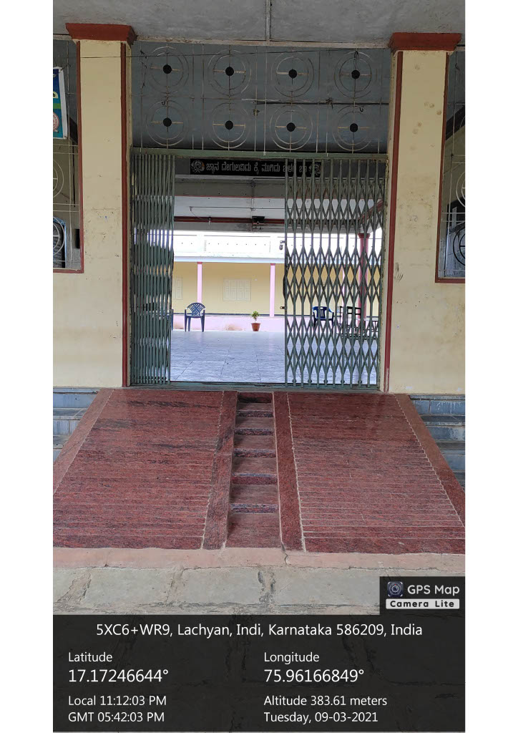

Built environment with ramps/lifts for easy access to classrooms.
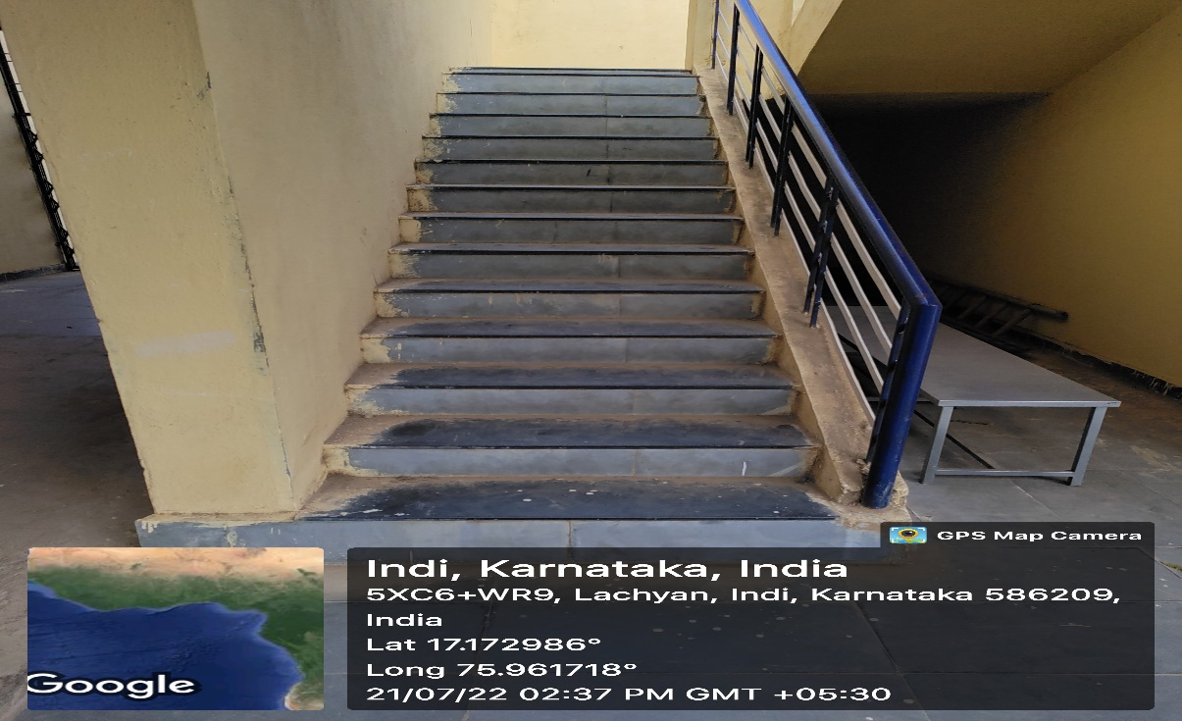
Built environment with ramps/lifts for easy access to classrooms.
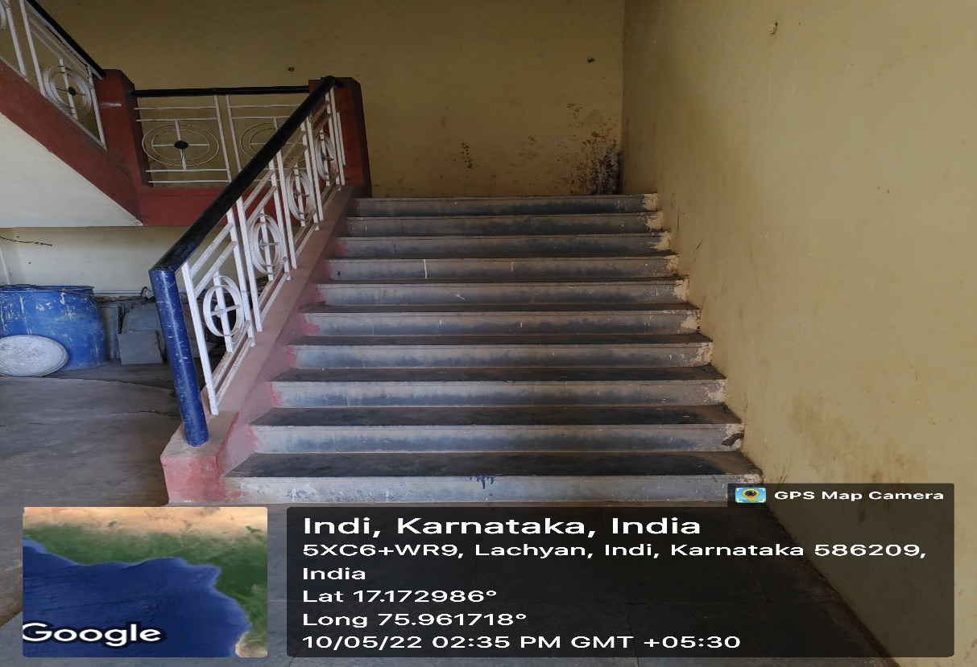

- DISABLED-FRIENDLY WASHROOMS: The differently abled friendly restroom is available in the campus. These accessible restrooms carry the fixtures and fittings that are comfortable and convenient to the differently abled people. Nonslip floor and grab bars provide easy access to the differently abled people.
DISABLED FRIENDLY WASH ROOM
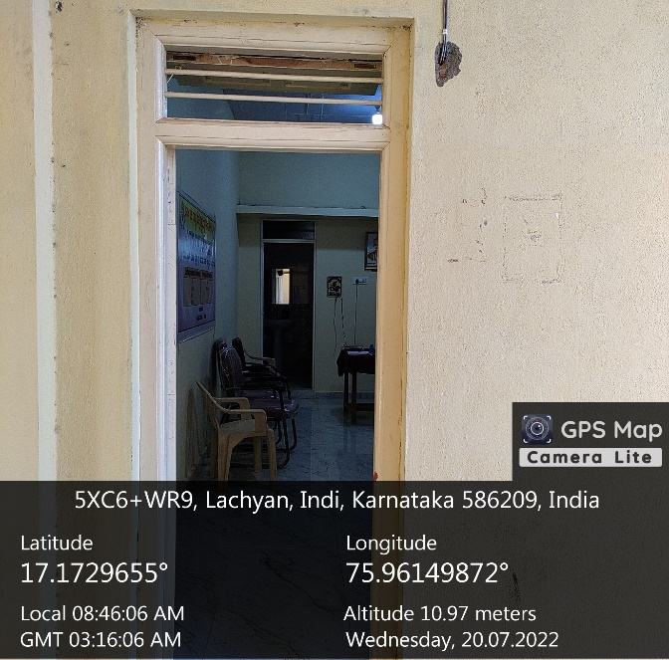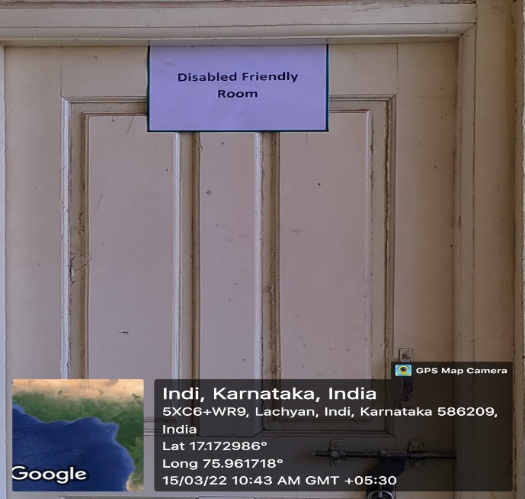
DISABLED FRIENDLY WASH ROOM
